**  
 DEPARTMENT OF MATHEMATICS**

**PROJECT RECORD**

**ON**

**UNLOCKING INSIGHT OF GLOBAL AIR TRANSPORTATION**

**FUNDAMENTAL OF DATA ANALYTICS WITH TABLEAU**

**TAMILNADU SKILL DEVELOPMENT CORPORATION, GOVERNMENT OF TAMILNADU,**

**NAAN MUDHALVAN PROGRAM**

**Submitted By**

**1. ANITHA GK (222106817)**

**2. SANGEETHA P (222106827)**

**3. VAISHNAVI M (222106830)**

**4. MUNIYAMMAL K (222106823)**

**(III B.Sc. MATHEMATICS)**

**CERTIFICATE**

THIS IS TO CERTIFY THAT THE PROJECT IS TITLED **UNEARTHING THE ENVIRONMENTAL IMPACT OF HUMAN ACTIVITY: A GLOBAL CO2 EMISSION ANALYSIS- DATA ANALYTICS WITH TABLEAU.** THIS PROJECT IS SUBMITTED BY. ANITHA GK (222106817) , SANGEETHA P (222106827) , VAISHNAVI M (222106830) , MUNIYAMMAL K (222106823)OF III B.SC MATHEMATICS, Dr. MGR JANAKI COLLEGE OF ARTS AND SCIENCE FOR WOMEN, CHENNAI IN FULFILLMENT OF THE REQUIREMENTS FOR **TAMILNADU SKILL DEVELOPMENT CORPORATION, GOVERNMENT OF TAMILNADU,NAAN MUDHALVAN PROGRAM**. THIS PROJECT WAS AN AUTHENTIC WORK DONE BY HIM UNDER MY SUPERVISION AND GUIDANCE.



**TABLE OF CONTENTS**

|  |  |  |
| --- | --- | --- |
| **S.NO** | **CONTENTS** | **PAGE NO** |
| **1** | **INTRODUCTION** | 5 |
|  | 1.1 OVERVIEW | 5 |
|  | 1.2 PURPOSE | 6 |
| **2** | **PROBLEM DEFINITION & DESIGN THINKING** | 7 |
|  | 2.1 EMPATHY MAP | 7 |
|  | 2.2 IDEATION & BRAINSTORMING MAP | 8 |
| **3** | **RESULT** | 9 |
| **4** | **ADVANTAGES & DISADVANTAGES** | 14 |
| **5** | **APPLICATIONS** | 16 |
| **6** | **CONCLUSION** | 17 |
| **7** | **FUTURE SCOPE** | 17 |
| **8** | **REFERENCE** | 18 |
| **9** | **VIDEO LINK** |  |

**INTRODUCTION:**

Air transport is one of the fastest modes of public transport which connects international boundaries. Air transport allows people from different countries to cross international boundaries and travel other countries for personal, business, medical, and tourism purposes. Although, air transport provides the fastest means by saving the time of journey, another aspect of air transport is the facilities and comfort level of the passengers.

There are lots of air transport companies such as Air India, Indigo airlines, Aeroflot, etc. Nowadays, there is a competitive environment among the airline industries. Every company is providing a variety of facilities to attract the passengers. The only motive is to improve their profit. Few years back, it was difficult to identify the needs and desires of passengers. But with the advancement of social media like Facebook, Twitter, etc., passengers are sharing their views on different types of airline facilities during their travel on [social media platforms](https://www.sciencedirect.com/topics/computer-science/social-medium-platform). This sharing of information plays a huge role to increase the competitiveness among the airline industries. It also provides a chance to improve their services and facilities for the traveller’s worldwide.

But the fact is how to analyse the need and important requirements of travellers just with the information they shared on social media. The millions of travellers traveling in the airlines and sharing their views on social media generate a huge amount of data. In this study, we use a dataset of different tweets. Tweet is a name given to the information sharing on Twitter platform. Twitter is the one of the most preferable information sharing platforms for all travellers. Wherever a traveller goes, whatever he does, he just tweets his view about his activity and experiences on Twitter.

Sentiment is another name for the view and opinion that is held or expressed. The sentiment may represent a feeling of joy, happiness, sadness, or sometimes anger. And this is what travellers’ tweets about on Twitter. Every journey on airlines can bring either pleasure or discomfort during travel for any passenger. If the traveller is not happy with the services, his tweet represents a sentiment of discomfort. If he is fully satisfied with the services, he will show a feeling of happiness in his tweet. The British airways further took it seriously and resolved the issues of the respective traveller.

Therefore, tweets do not only allow the airlines to sort out the problems of individual passengers but also help them to improve their services. The one or two people are just exceptions. The important thing to be concerned is the opinion of majority of travellers. To understand the psychology and opinion of the majority of travellers from all around the world, we must look into everyone's view, which is a rather impossible job. As millions of people are traveling daily from one place to another and tweeting about their journey experience, it creates a huge database of tweets. Therefore, it is important to use a technique which has the power to analyse such a huge data of tweets.

Here the machine learning role comes into existence. Machine learning is a set of techniques such as classification, clustering, association rule mining, and anomaly detection. These techniques are very much powerful and have been widely used in different applications. In this chapter, we are using machine learning techniques for sentiment analysis of airline tweets data. The rest of the part is organized as follows: Section 2 introduces the literature survey which consists of different important related work and their achievements. Section 3 covers the concept and architecture and Section 4 covers an overview of the techniques being used in this work.

**PURPOSE:**

Companies in the aviation industry are sought-after employers for workers with a wide variety of professional qualifications. Beyond this, air transport also secures employment and value creation in Germany as a business location. This is because air transport connects people and markets worldwide.

Aviation is of outstanding importance for Germany as a business location. The companies in the aviation industry offer employment for hundreds of thousands of employees with a wide variety of professional qualifications. However, the actual importance of air transport goes far beyond the jobs in aviation: on the one hand, air transport makes a major contribution to people’s individual mobility and thus promotes international understanding and cultural exchange. On the other hand, aviation connects German companies with important supplier and sales markets all over the world. Air cargo plays an important role in this – especially in trade with countries outside Europe.

**PROBLEM DEFINITION & DESIGN THINKING :**

**EMPATHY MAP:**

An empathy map is a collaborative tool teams can use to gain a deeper insight into their customers. Much like a user persona, an empathy map can represent a group of users, such as a customer segment. The empathy map was originally created by Dave Gray and has gained much popularity within the agile community Assemble your team and have them bring any personas, data, or insights about the target of your empathy map. Print out or sketch the empathy map template on a large piece of paper or whiteboard. Hand each team member sticky notes and a marker. Each person should write down their thoughts on stickier. Ideally everyone would add at least one sticky to every section. You might ask questions, such as:

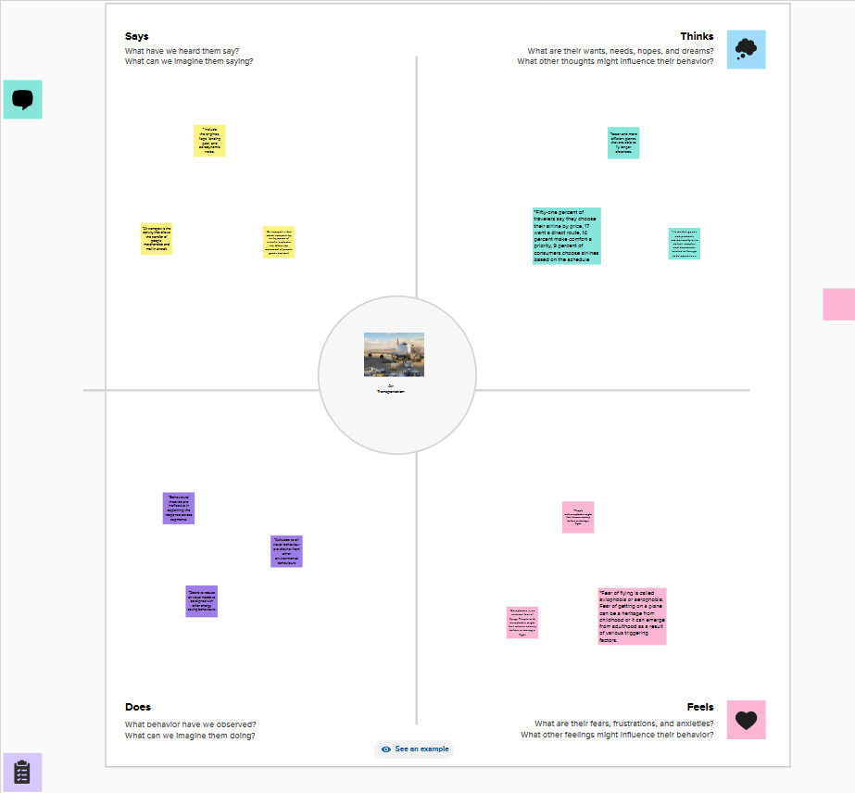

**BRAINSTORMING MAP:**

Brainstorming is a method of generating ideas and sharing knowledge to solve a particular commercial or technical problem, in which participants are encouraged to think without interruption. Brainstorming is a group activity where each participant shares their ideas as soon as they come to mind. At the conclusion of the session, ideas are categorized and ranked for follow-on action.When planning a brainstorming session it is important to define clearly the topic to be addressed. A topic which is too specific can constrict thinking, while an ill-defined topic will not generate enough directly applicable ideas. The composition of the brainstorming group is Important too. It should include people linked directly with the subject as well as those who can contribute novel and unexpected ideas. It can comprise staff from inside or outside the organization.

**22wwwwww**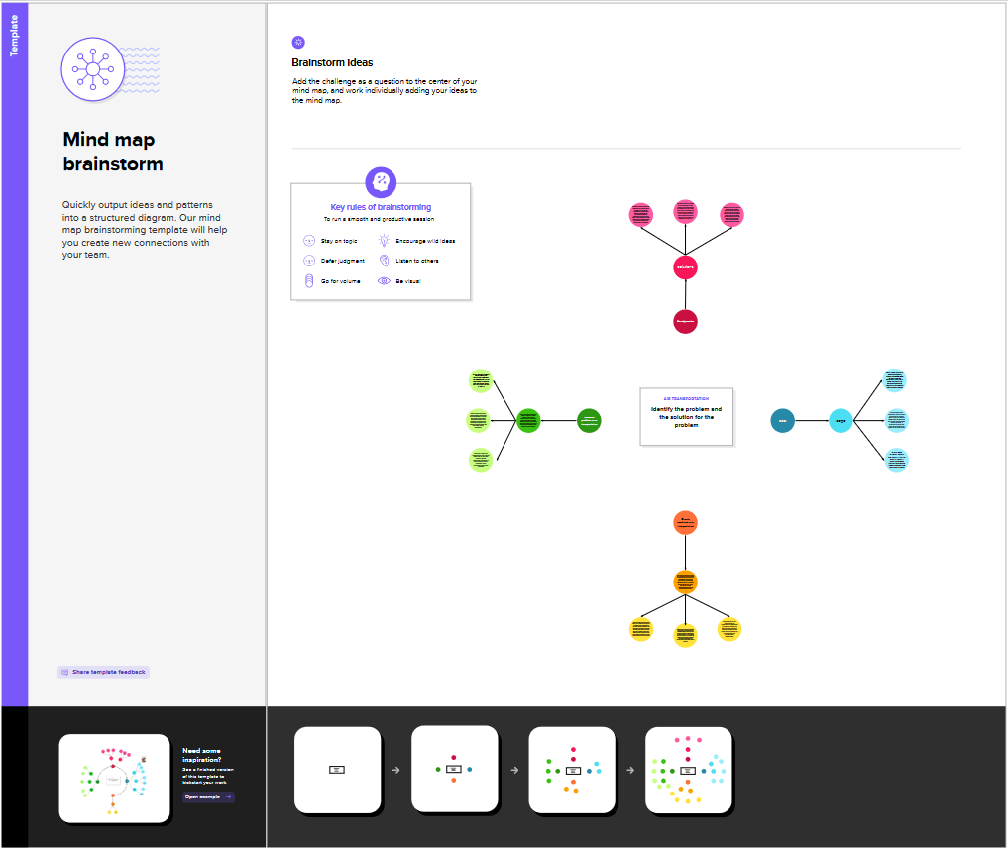

**Results:**

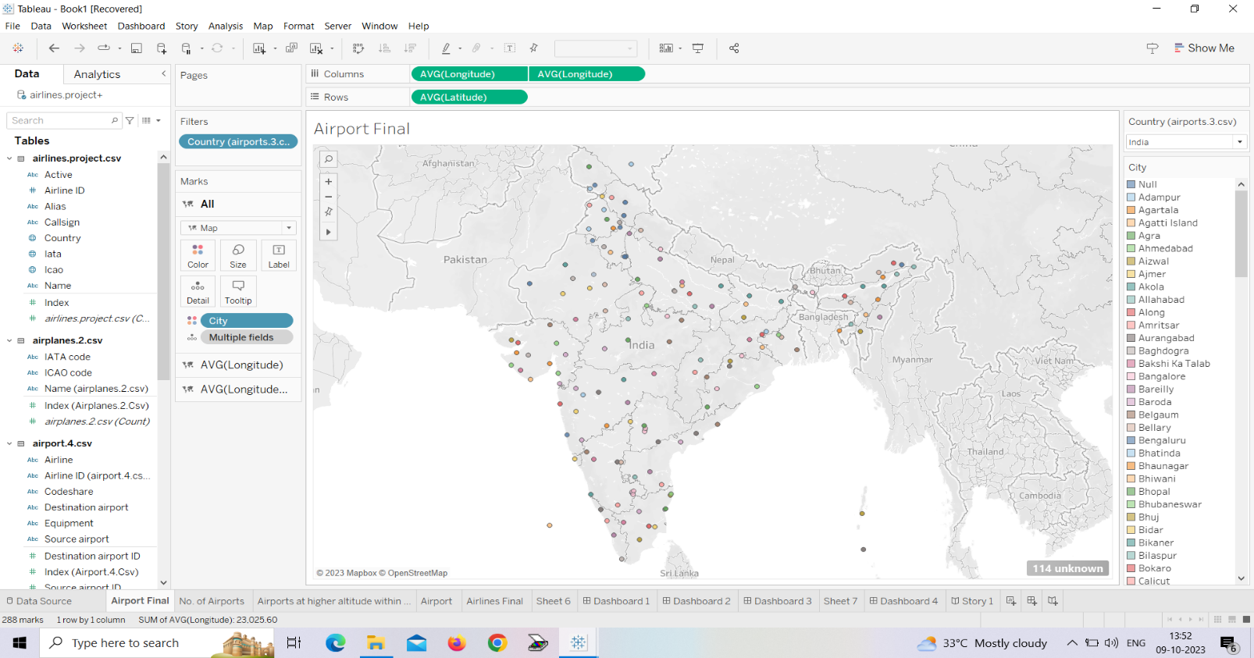

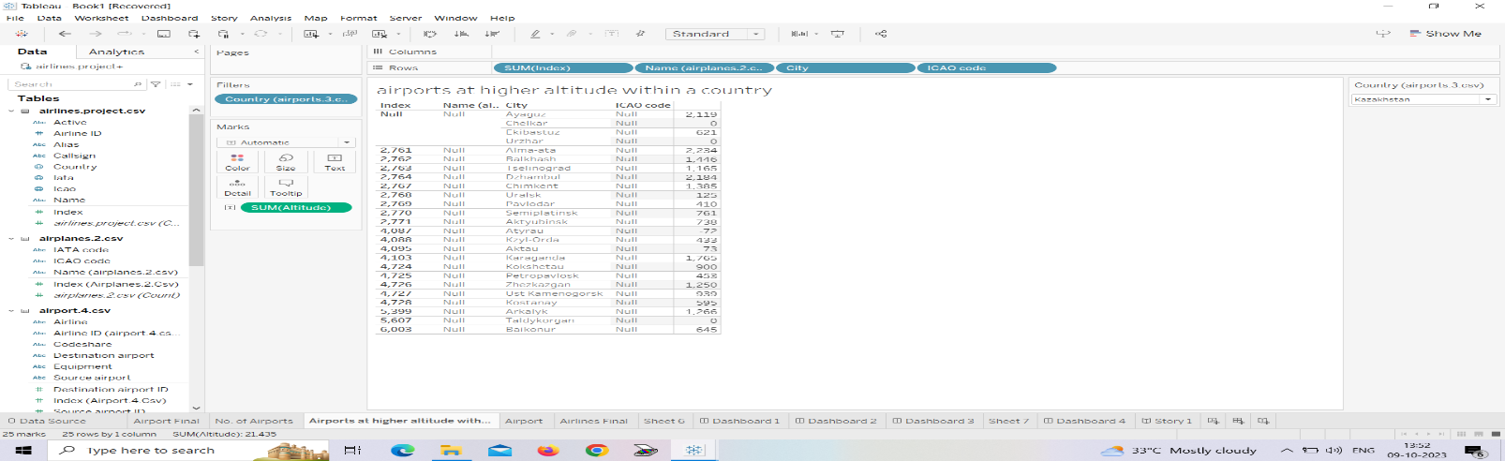

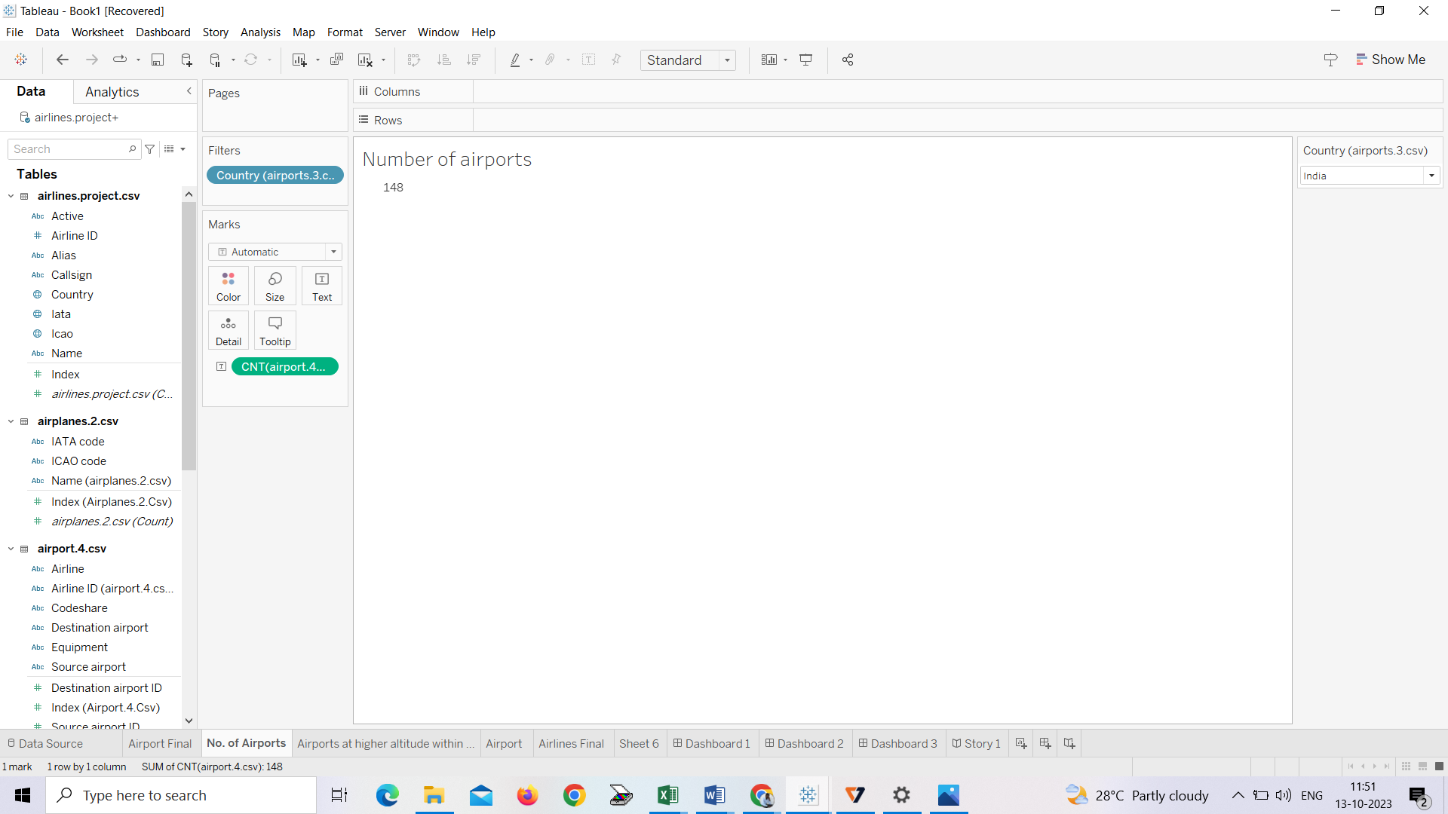

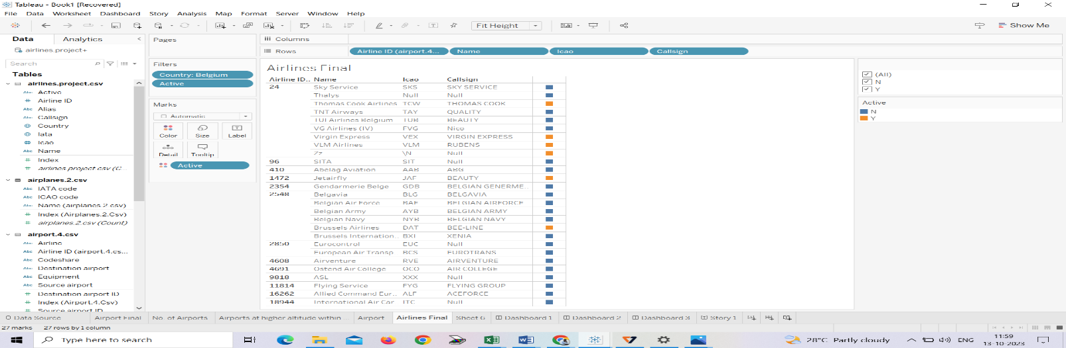

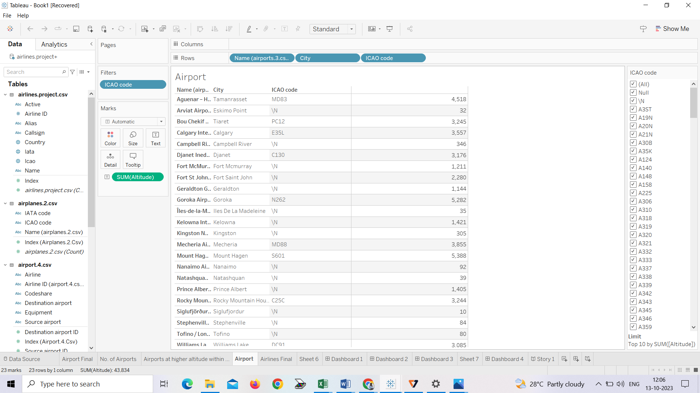

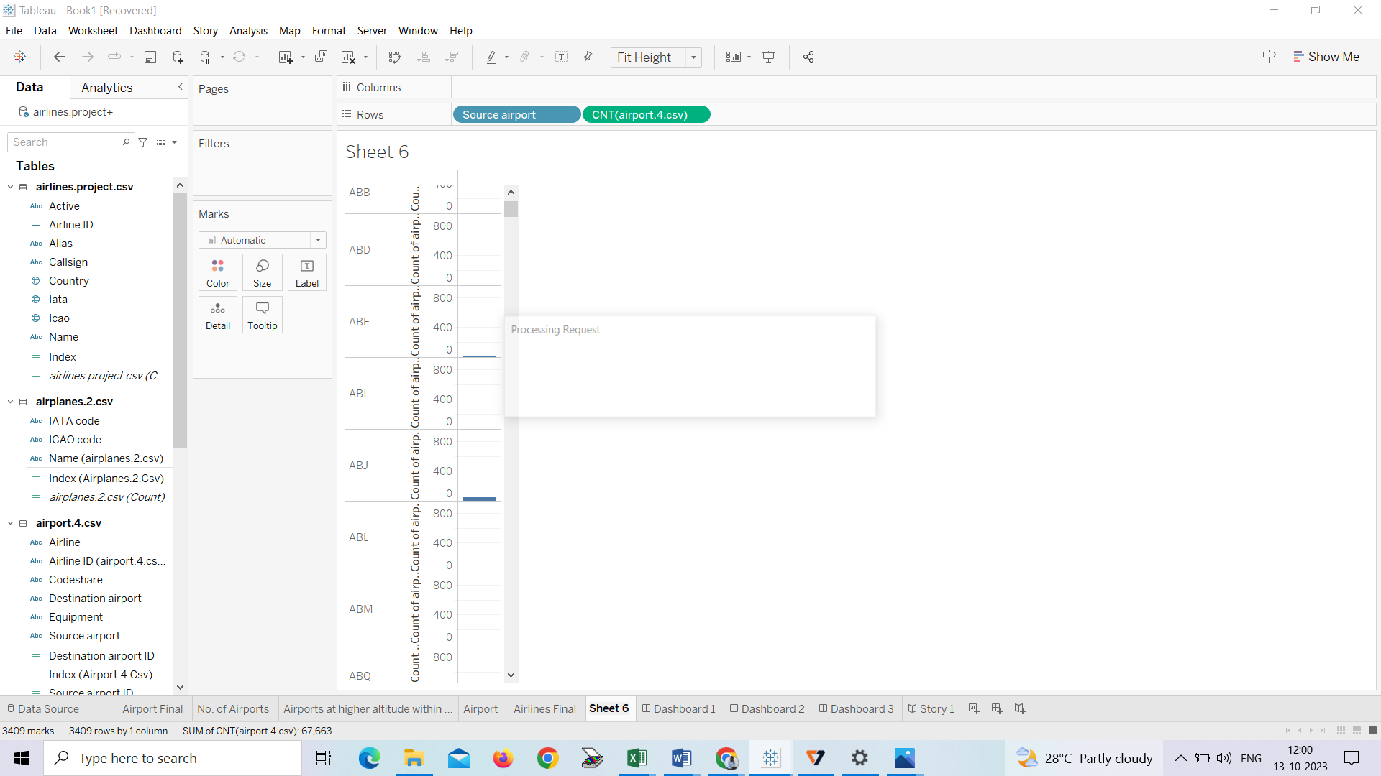

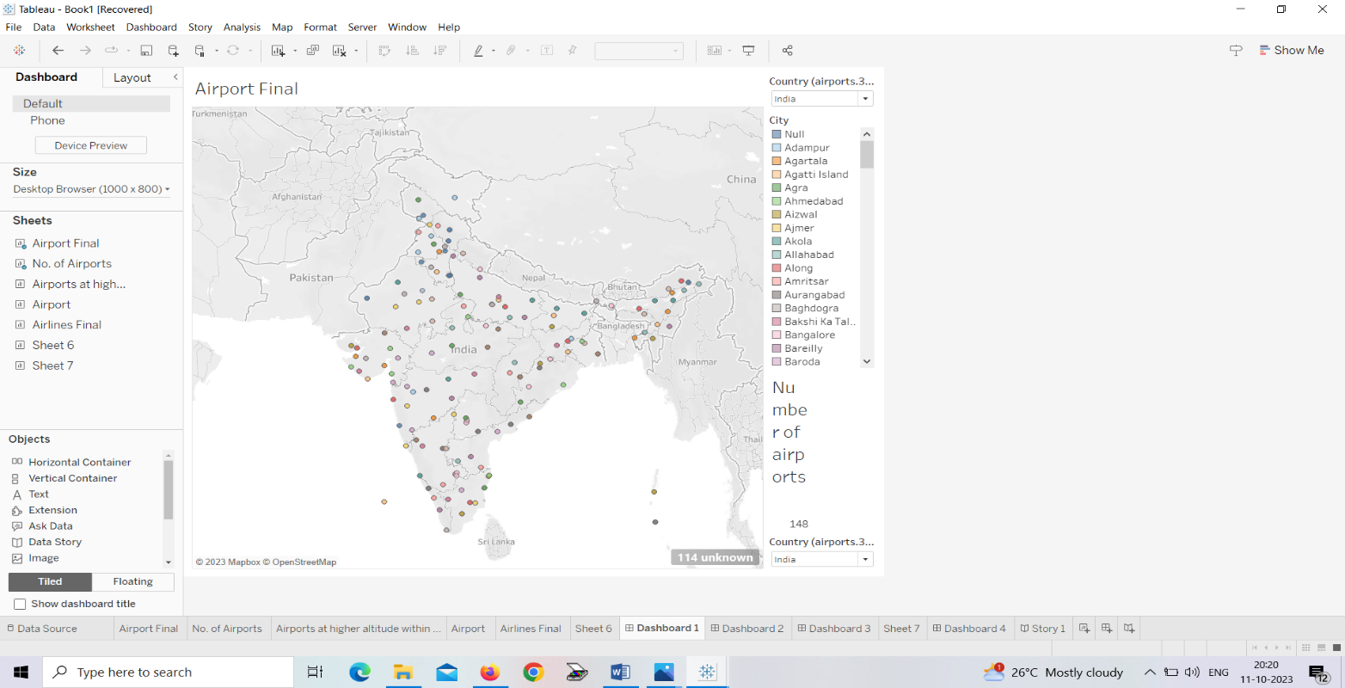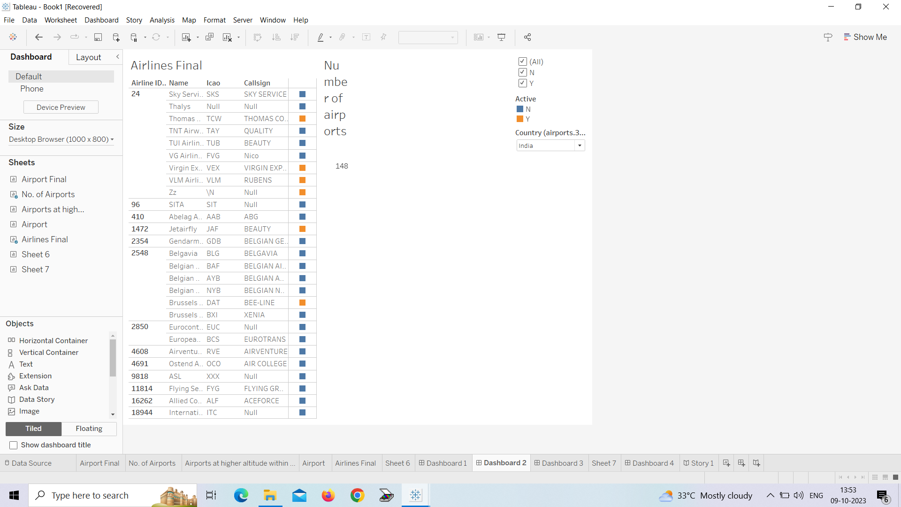

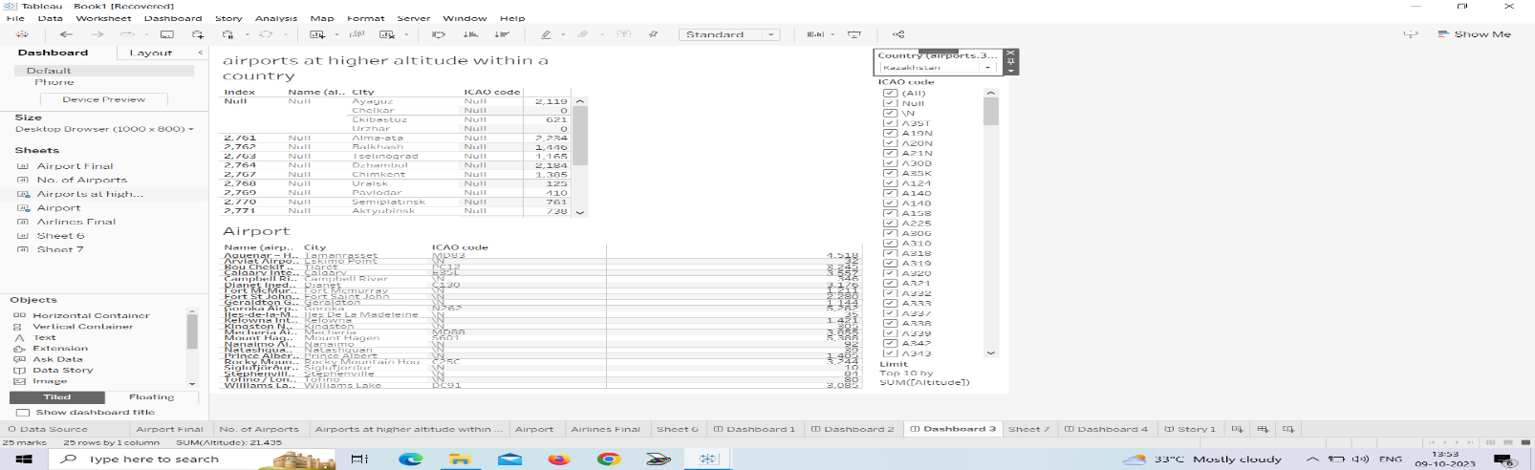

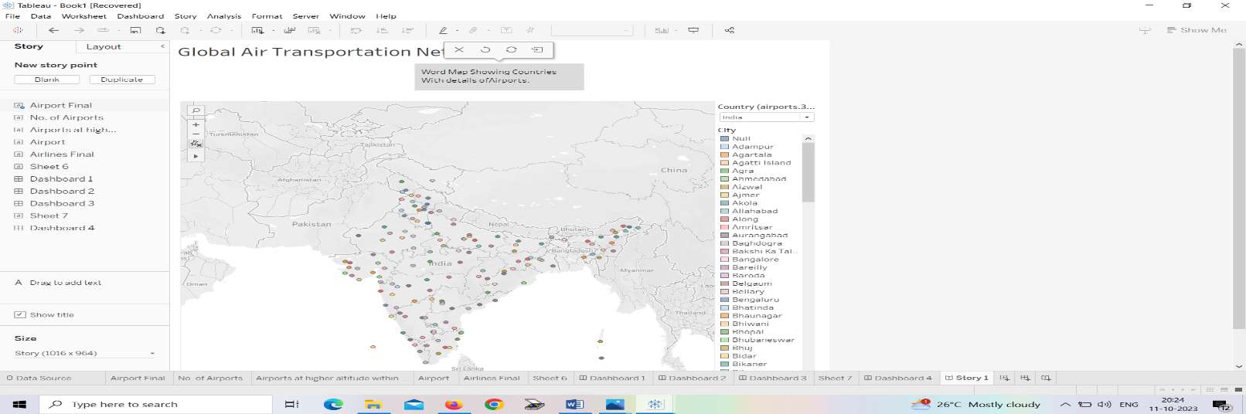

<https://palic.tableau.com/app/profile/vaishnavi.m8778/viz/Dashboard1>

<https://public.tableau.com/app/profile/vaishnavi.77/viz/Dashboard2_16968425963810/Dashboard2?publish-yes>

<https://public.tableau.com/app/profile/vaishnavi.a877/vzz/Dashboard)_16968477109590/Dashboard3?publish>

<https://public.tableau.com/app/profile/Vaishnavi.88778/viz/Dashboard4>

https://public.tableau.com/app/profile/vaishnavi.m77/viz/story

**Advantages and Disadvantages:**

**Advantages:**

### 1. High Speed

**Air is the type of freight capable of traveling long distances in short periods of time. This makes this model an optimum choice if the client has an urgent need to ship a product or if their freight demands special standards of protection or acclimation. It is the quickest transport mode and is therefore ideal for long-distance transport of goods. It takes less time.**

### 2. Fast Service

**Air transportation offers convenient, reliable and fast services of transport. It is considered the cheapest way to ship peregrinated goods. It offers a standard, convenient, reliable and fast service.**

### 3. Send almost everywhere your freight

**In regions that are not readily accessible to other modes of transport, air transport is considered to be the only means of transport. Open to all regions, irrespective of land interference. A vast network of airlines covering nearly the whole globe is available for many airlines. This ensures that the package can be sent almost anywhere.**

### 4. High Standard of Security

**High standard of protection with a low risk of robbery and injury. Shipping by air has a high degree of security since airport safety restrictions on cargo are strictly enforced. Tightly controlled airport controls also minimise cargo theft and loss.**

### 5. Natural Route

**An aircraft can fly to any location without seeing any natural obstacles or barriers. Since customs formalities are easily compiled. It eliminates the need for more time to seek clearance. Air travel is used for relief operations during earthquakes, floods, accidents, and famines.**

### 6. There is less need for heavy packaging

**Air exports, in general, entail less hard packaging than ocean shipments. This ensures you save both time and money by not having to provide extra packaging services.**

**DISADVANTAGES**

**Climate conditions that are adverse: Extreme weather will cause planes to be grounded and airports to close, halting shipments for several days and rendering the service ineffective.**

### 1. Risky

**Air travel is the riskiest mode of transport, since there can be considerable losses to goods, customer and crews as a result of a minor crash. Compared to other means of travel, the risks of collisions are higher.**

### 2. Cost

**Air travel is considered to be the most expensive means of transportation. The cost of maintaining aircraft is higher and the costs for the building of aerodromes and avian are much higher. That’s why air travel is so expensive that it gets beyond ordinary people’s grasp.**

### 3. Some Product Limitation

**There is a whole variety of materials not suitable for such products, from explosives, gases, batteries, fired solids and liquids, which cannot be shipped by air to name but a few.**

### 4. Capacity for Small Carriage

**The aircraft have no room and therefore are not ideal for carriage of voluminous and cheaper materials. As is seen for rails, the load volume cannot be raised.**

### 5. Enormous investment

**Air travel calls for enormous spending in aerodrome building and servicing. It also calls for professional, qualified and qualified staff that need a significant investment.**

**APPLICATION**

Aviators throughout the world use the Global Positioning System (GPS) to increase the safety and efficiency of flight. With its accurate, continuous, and global capabilities, GPS offers seamless satellite navigation services that satisfy many of the requirements for aviation users. Space-based position and navigation enables three-dimensional position determination for all phases of flight from departure, en route, and arrival, to airport surface navigation.

The trend toward an Area Navigation concept means a greater role for GPS. Area Navigation allows aircraft to fly user-preferred routes from waypoint to waypoint, where waypoints do not depend on ground infrastructure. Procedures have been expanded to use GPS and augmented services for all phases of flight. This has been especially true in areas that lack suitable ground based navigation aids or surveillance equipment.

New and more efficient air routes made possible by GPS are continuing to expand. Vast savings in time and money are being realized. In many cases, aircraft flying over data-sparse areas such as oceans have been able to safely reduce their separation between one another, allowing more aircraft to fly more favorable and efficient routes, saving time, fuel, and increasing cargo revenue.

Improved approaches to airports, which significantly increase operational benefits and safety, are now being implemented even at remote locations where traditional ground-based services are unavailable. In some regions of the world, satellite signals are augmented, or improved for special aviation applications, such as landing planes during poor visibility conditions. In those cases, even greater precision operations are possible.

The good news for the aviation community is that GPS is being constantly improved and modernized. A main component of the ongoing civilian modernization effort is the addition of two new signals. These signals complement the existing civilian service. The first of these new signals is for general use in non-safety critical applications. The second new signal will be internationally protected for aviation navigational purposes. This additional safety-of-life civilian signal will make GPS an even more robust navigation service for many aviation applications.

The second safety-of-life signal will enable significant benefits above and beyond the capabilities of the current GPS services. The availability of this signal offers increased instrument approach opportunity throughout the world by making the use of dual-frequency avionics possible. Dual frequency means that errors that occur in the signals due to disturbances in the ionosphere can be significantly reduced through the simultaneous use of two signals. This will improve the overall system robustness, to include accuracy, availability, and integrity, and will allow a precise approach capability with little or no ground infrastructure investment.

Reliance on GPS as the foundation for today and tomorrow's air traffic management system is a major part of many national plans. Those aviation authorities that are moving forward with GPS have observed and documented reductions in flight time, workload, and operating costs for both the airspace user and service provider. GPS also serves as an essential component for many other aviation systems, such as the Enhanced Ground Proximity Warning System (EGPWS) that has proven successful in reducing the risk of Controlled Flight into Terrain, a major cause of many aircraft accidents.

**CONCLUSION:**

The air transport industry is not only a vital engine of global socio-economic growth but is also of vital importance as a catalyst for economic development in most countries and for many regions within each country. Its importance arises not only from its ability to facilitate the movement of people but also its ability to expedite the movement of goods. Currently, rising operating costs, stoked by the high price of aviation fuel combined with slowing or even negative demand growth, will lead to dramatic restructuring of the airline industry and the collapse of many airlines especially smaller ones, reduced access to air services for both passengers and freight may put many communities at a disadvantage. The air transport industry needs not only to be financially sound to be effective as an economic catalyst for growth but also to be environmentally responsible. Governments need to be sensible, transparent and long-term in their approach. Priority must be given to tackling obstacles such as inefficient and fragmented ATMs, restrictive air service agreements, inadequate airport infrastructures and unjustified government charges and taxes. The development of more fuel efficient aircraft and engines must also be encouraged.

**FUTURE SCOPE**

**India is currently the third largest aviation market in the world, with over 340 million passengers traveling by air annually in 20191. The industry has a number of domestic and international airlines, as well as a large network of airports. The future of the aviation industry in India is likely to see continued growth and expansion, driven by factors such as a growing middle class, increased tourism, and government policies supporting the industry. However, the industry is also likely to face a number of challenges, including infrastructure constraints and competition from low-cost carriers.**

The market size of the aviation industry in India has grown significantly in recent years, driven by a combination of factors, including a growing middle class, increased tourism, and the government’s efforts to open up the sector to foreign investment. With growing middle class, which is expected to drive demand for air travel. As more people in the country have disposable income, they are likely to take more trips, both within India and abroad. This trend is likely to continue in the coming years, providing a boost to the industry. In the financial year 2021, the industry recorded revenues of over $20 billion, and it is expected to continue growing in the coming years.

REFERENCE:

**Citation**(2015), "References", [Kazda, A.](https://www.emerald.com/insight/search?q=Anton%C3%ADn%20Kazda) and [Caves, R.E.](https://www.emerald.com/insight/search?q=Robert%20E.%20Caves) (Ed.) *Airport Design and Operation*, Emerald Group Publishing Limited, Bingley, pp. 555-559. <https://doi.org/10.1108/978-1-78441-870-020153032>

ACI (2005, December). Survey on apron incidents/accidents 2004. Geneva: ACI World Headquarters. Retrieved from <http://www.aa2000.com.ar/boletin/downloads/APRON_2004_FINAL_PDF.pdf>. Accessed on January 6, 2015.

ACI, DKMA: Ground Transportation. (2012). Airport Service Quality Best Practice. Benchmarking the Global Airport Industry. Report published by ACI.

Airbus Global Market Forecast 2014–2033 . Airbus, Toulouse. Retrieved from <http://www.airbus.com/company/market/forecast/>. Accessed on January 3, 2015.

Airline profiler . International low-cost airline market research. Retrieved from <http://www.airlineprofiler.eu/>. Accessed on January 4, 2015.

VIDEO LINK:

<https://drive.google.com/file/d/16zCjxeDPXHUQykKKIpZ8D9jHZ5RhpXXf/view?usp=drive_link>